ROOPAM TEXT I LE
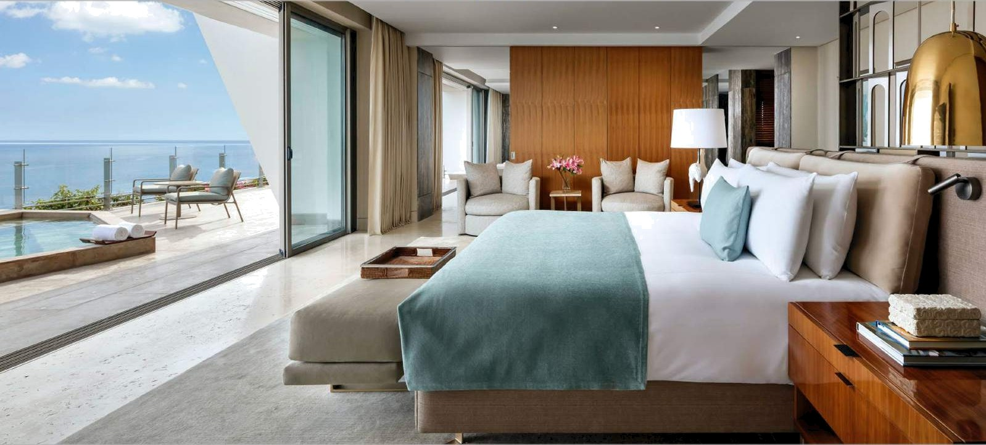
I N D I A

HOS PI TALITY LI NEN
P R 0 D U C T C ATA L 0 G

Why “č?’. .ø "?
Our “Elegoncia" brand products are manufactured using only the finest raw materials and croftmanship. We use 00% Indian Cotton which is superior in quality, soft and luxurious to the touch. Drawing its strength from Indian Sate Gujorat’3 renowned apparel industry, our products are safe, user friendly and well designed.

With “Elegancía", experience the of premium quality, affordable hotel, home & hospital utility linen that covers a range of products including Bedsheet, Pillow & Cushion FillerS, Pillow & CUShion Covers, Duvet, Duvet Covers, Mattress & Pillow Protector, Bath Towel, Hand Towel, Face Towel, Baìh Mat, Bed Runner Set, etc

ABOUT US
We are delighted to introduce you to the home of cotton products. Not everyone has heard of Elegancia. but here's why you really should know more about us. Elegoncia has a hİStory going back more thana decade so we know a thing or two about cotton. Since 1998 we have been a trusted supplier to some ot the best hotels in the world. but more recently we have come to realise thot every hotel should be able to benefit from our wonderful range of high quality prodUCts. ParticUlarly becoUse , as a manufacturer & wholesaler , we can offer everyone these wonderful products at great prices. ThiS brochure shows some of the vasì ranges we stock , so join the exclusive club that have already discovered Elegancia.

HOTEL LIN EN
- B E D LI N E N
  - B e d Sh e et s
  - P i I I o w C o v e rs
  - C o m fo rt e r/ D u ve t s
  - D u v e t c o v e r s
  - P i I I o w s & C u s h i o n s
  - P i I I o w P r o te c tor
  - M a It r e s s P r o te c t o r
  - B e d R u n n er S e t
  - BI a n ke t
- BAT H LI N E N
  - B at h To w e I s
  - H a n d To w e I s
  - Fa c e Tow e I s
  - B aI h M a t s
  - P o o I To w e I
  - B at h R o be s
- BA N Q U ET LI N E N
-Ta b I e C Io t h s
-Ta b ie N ap k i n s
HOSP ITA L LIN E N
- B e d Li n e n
- Pr o t e cI or s
- B at h L i n en
- BI a n ke t s

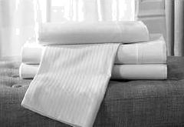
Page 4
HOTEL BEDSMEETS

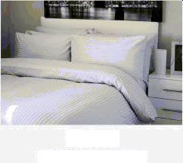

Page 8
DUVET COVERS

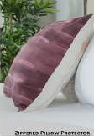
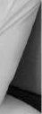
Page 12
PILLOW PROTECTOR



Page S
HOSPITAL BEDLINEN

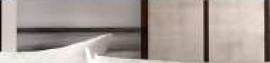



Page 9
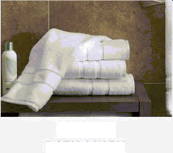
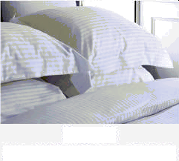
PILLOW & CUSHIONS

Page 10
BATH LINEN

Page 6
PILLOW/CUST ION COVERS

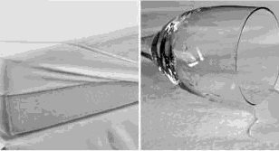
Page 13
WATERPROOF MATTRESS PROTECTOR


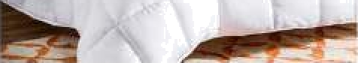

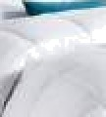
Page 7
COMFORTERS/QUILT5

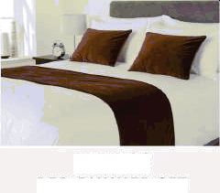

Page 11
BED RUNNER SET

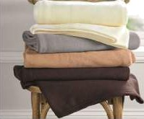
Page 14
POLAR FLEECE BLANKET

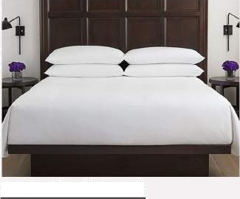

P I a in B e d sh e et

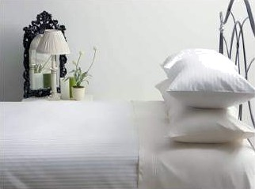
S a tin S trip e B e ds h e e t
Our collection of Hotel Bed Linens ore 5 Sta r hotels a pproved, & hove stood the test of stringent quality meoSUreS. Avoi!o ble in Plain Perco ie, Plain Satin & Satin Stripes Fobric, tnese comes in voriOUS Shades & desig ns which ore suito ble to adorn a varitey of noUtehold taste 8 decor, we provide FLAT & FITTED be dt he et.
Fobric Types .
1 00% C otto n S a tin Stri pe S [21 0 T.C to 400 T. C] 00% C otto n PIoin S a tin [ 180 T. C to 400 T.C]
1 00% C otto n PIoin Per co le [ 50 T. C to 400 T.C]
Sta ndard Sizes For F LAT Bed Sheets

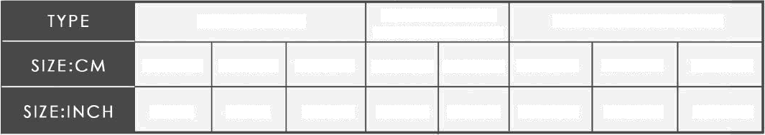
SI NGLE BED
DOU BLE B ED
STANDARD+QUEEN
DOU BLE BED KING
l37x228 l50x228 180x274 225x235 223x2Z4 253x274 274x2Z4 274x30O
54x90
58x90
70x108 90x100 90x108 100x108 108x108 108x118

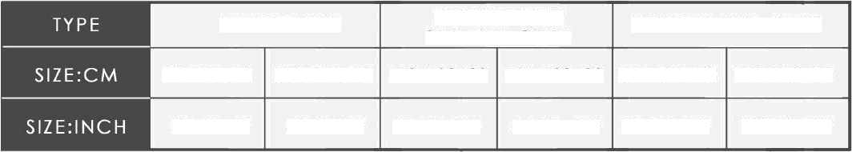
Sta ndord Sizes For FITTE D Bed Sheets :
SI NGLE BED
DO UBLE BED
STANDARD +QUEEN
DO U BLE BED KIN G

90xl80+20 | l20x180+20 | l50x180+30 | 167xl80+30 | l80x)80+30 | l80x200+30
36x72+8" | 48x72+8" | 60x72+ 2” | 66x72+ 12” | 72x72+ 2" | 72X78+ 2”

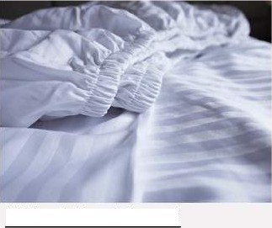
*Polycotton/Cottonpoly combination con be provided as per client request.

Fitt e d B e ds he eI
*Sizes of bed sheets con be cuStOmized oS per client request.
*Logo Printing or Labelling of Hote! nome con be provided oS per clients request.

P a g e. 04

We mo nufoCt Ure hUge range of Hospit a Bed Linens which are appro ved !n G ov erment Hospit a!s &Premium Ca te gory Privo te HoS pito Is too. Ava la ble in Plain & So tin W ea ve whic h c ome S in va rio us Co lor Shades m oinI y include s [White, Sk yBlue, Pin k, Green, Ivory, Vat Green etc.] We ore main!y specialize d in Cus to mized HoS pitol Nomes printed on bedt he eIS & illow covers as per clientt requirement. be provide FLAT & FITTED be dshe e ts
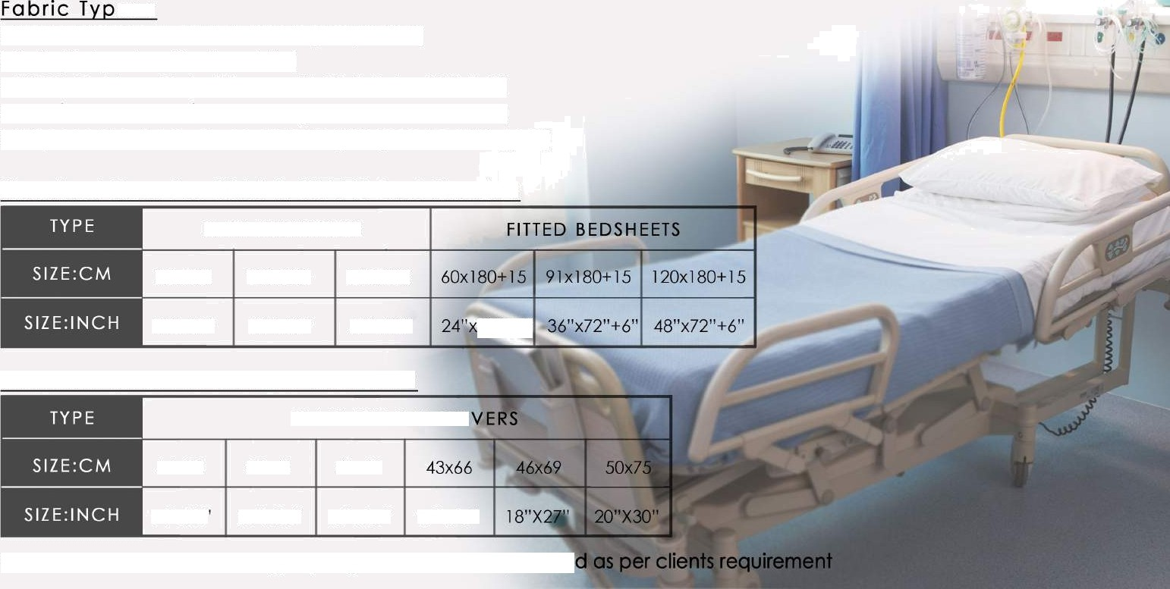
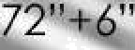
es :
>Swist Cotton & D ull C otto n P olyes te r]
> P.C [P o I y e SI er Co tt on Mix]
- 00% C o tt o n P loin W ea v e [ 1 20 T.C to 20 0 T. C
- 1 00% C o tt o n S aI in W ea v e [ 144 T. C t o 30 0 T. C]
>Dis poto ble No nwoven Fa b tic [20 gt m to 1 00 gt m]

Sta ndord Sizes For F LAT & FITT E D Be d S heets :
F LAT B E DS H EETS

75x180 | 1 20x220 | 145x225
30"x72" | 48"X87" | 57"x90"

Sta ndord Sizes For PILLOW COVERS :
PLAIN PI LLOW CO

38x59 38xal 41xa3

14"x23’ 15“X24” 16"X25" 17"X26"
”Customized Bedsheet Printing, Dyeing 6 Sizes con be providé

P a g e. 05

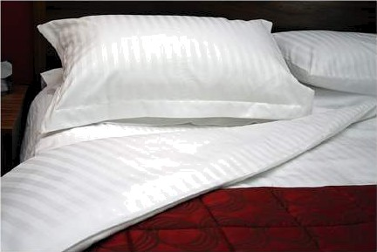
Our collec tion of Hotel Bed Linens ore 5 Star hotels opprov ed, & hove stood the test of stringent quolit y measures. Available in Plain P ercole, Plain Satin & Satin Stripes Fa bric, these comes in various shades & designs which ore suitable to adorn a varitey of household taste & decor.

Fabric Types :
100% Cotton Satin S tripe5 [210 T. C to 400 T. C] 100% Cotton Plain Satin [ 180 T.C to 400 T.C] 100% Cotton Plain Perc ale |150 T.C to 400 T.C]



Sta n d ord Sizes For PLAIN CUSHION GOVERS:
  - PLAIN CUSHION COVERS

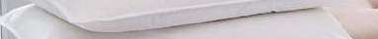
30x30 30x45 40x40 45x4ñi 50x50 60x60

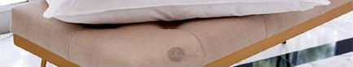
12"xi 2" 12"X18" 16"X 6" 18"X 8" 20"X20" 24"X24"


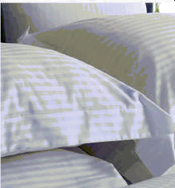
Stan d ord Sizes For PLAIX PILLOW COVERS :
  - PLAIN PI LLOW COVERS

36x59 | 38X6 i | 4J x63 | 43x66 | 46x69 | 50x75 | 50X91
4”x23" | 15“X24" | 16"X2S" | 17"X26" | 18"X27" | 20"X30" | 20"X36’

”Customized Logo Printing, Dyeing & Sizes can be provided as per clients requirement
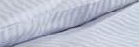

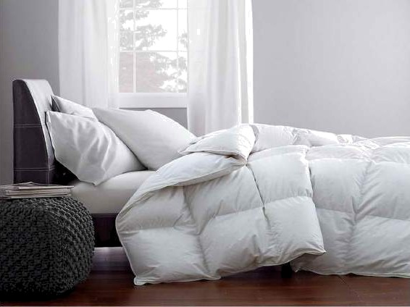
A DUVET which is also now as Comforter/Quilt is only good as its filling. The Ele goncio' duvets come in a variety of tizer 6 ore crafted from fillin g made from the synthetic polyfiber & micropoly. DuvetS hove tne benefit of being both duro ble & naturally breathable kee pin g you cozy. The syntnetic fiber filling duvets ore desig ned to provid e the feel & comfort of a n oturol down duvet. They combine soft textUres, weightless warmth & ore hypoo llergenic.

Sh elI Fa bric Types :
>Heavy Pe c he d Mic ro Fa bri ct

>Mic ro S at in Stripe S
- 00% C otto n Ploi n Weave [ 1 20 T.C to 200 T. C
>D!s posab ie N o n wo v en F abric [20 Q SITS tO 1 0 0 q SiTi]
Fi ber Filling Types & GSM:
>Micro Poly Fi ber [ 1 OOGS M to 300GS M]
>Synthe tic P oly Fi ber [ 1 OOGSM to 400G SM]
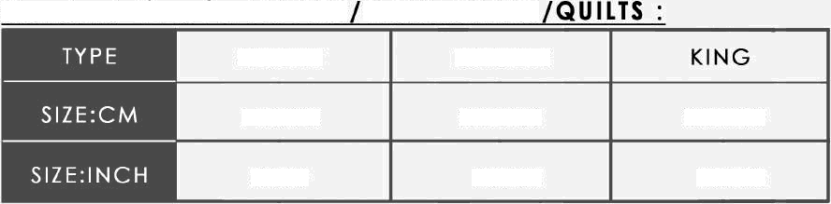
Sta nd ord Sizes for bUVETS COMFO RTERS
SINGLE
DOUB LE
47x225
225K250
225x270
58x90
90x 00
90x108
*C ustomizotion oS per GSm Filing Fiber, Fabric & Size co n be done as per client re quirement S.

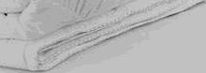
P a g e. 07

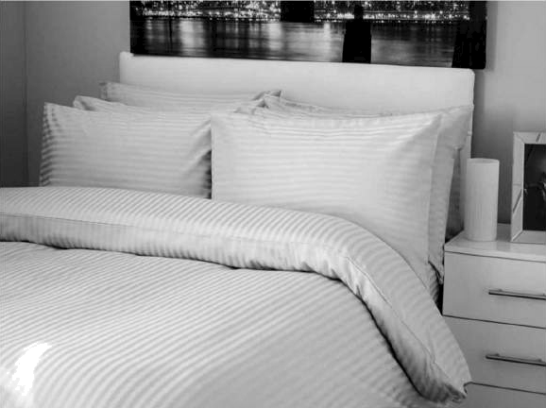
Our col Dec tion of Hotel Bed Linens ore 5 Star hotels oppro ve d, & hove stood the test of stringent q Uo lity me osur e S. Avoilo ble in Plain Percole, Plain Satin & latin S tripe s Fobric, these comes in various shades & designs which are SUitable to adorn a v aritey of houtehoId taste 6 decor, we provide with Zipper, with Flop 6 with Velcro DUvet Covers

Fo bric Types :
1 00% C otto n S a tin Stri pes [2 0 T.C to 400 T. C] I OOH C otto n PI oin So ton [ 180 T. C to 400 T.C]

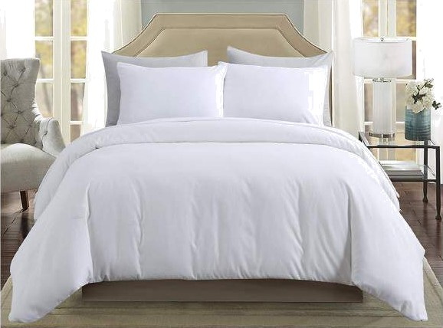
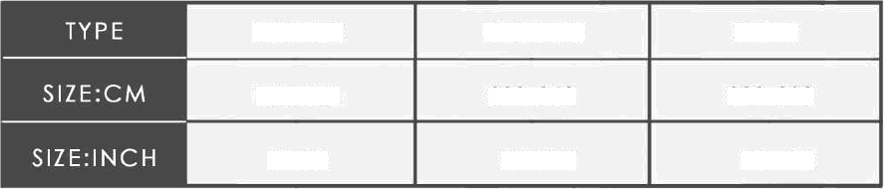
1 00% C otto n Pio in Perc a le 150 T, C to 400 T.C] S tondord Sizes For D UV ET COVERS :
SINGLE
DOUB LE
G KIN
52x232
232x260
232x280
d0x92
92x102
92xll0

”Polycotton/Cottonpoly combination can be provided as per client request
*Sizes of duvet covers can be customizes as per client request.
’Lopo Printing or LabelTinp of Hotel nome can be provided as per client request,

P o 9 e . 08

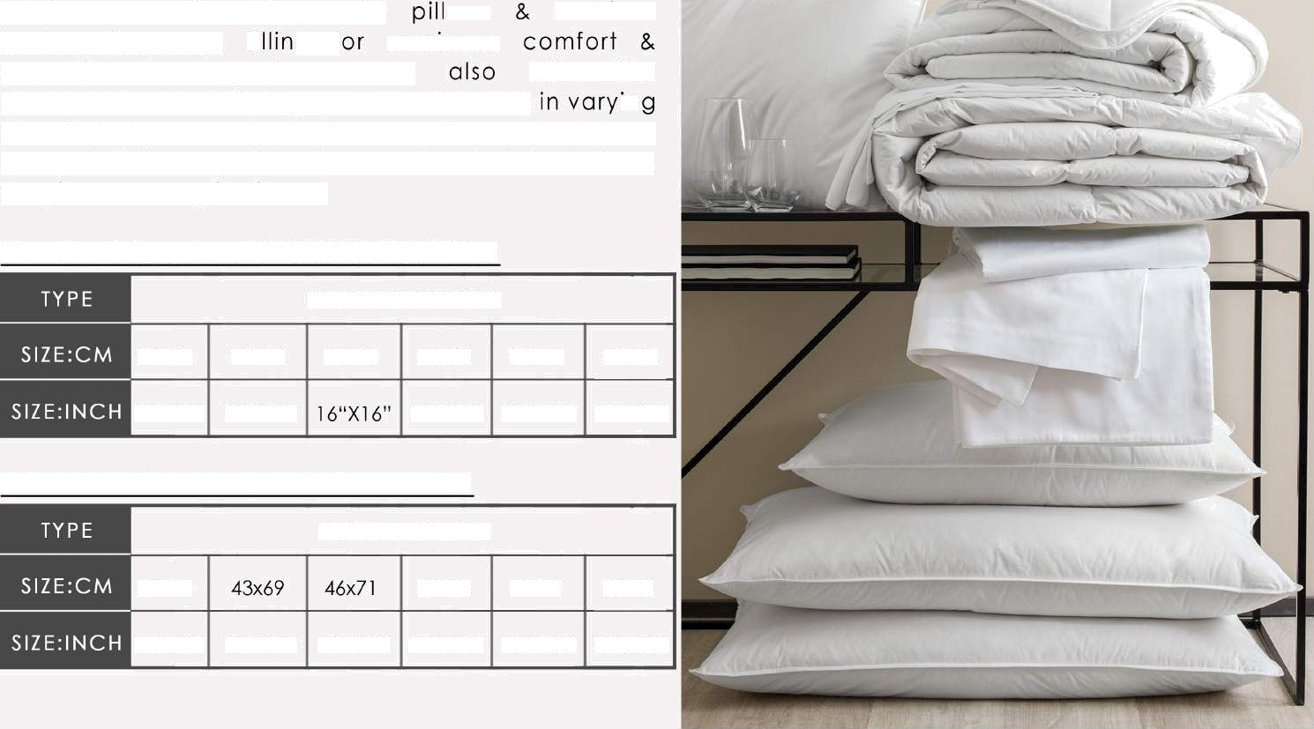
Our range of pillows & cushion fillers ore Ie other soft, flu fly & Swee t d reo m S ap pro ved. Our expertise in tne field ensures the Elego ncio’ ows c usnions feature improved fi g f maximum
pe oc eful tle eping hoU rs. We offer tne convenienc e of selec ting pillows 6 C UShions in Sizes & d esign S IO c a ter I o the versatile needs of 5 Sta r IUxury ho te Is as weII basic non star note IS, lo dge S, hospito Is & mony institutes.

Sta ndord SiZes For CUSH ION FI LLERS
P LAIN C US HIONS

30K30 | 30x45 | &K40 | 45K45 | 50x50 | 60K60
12"xJ 2" | 2"XJ 8" |  | 8"X 8" | 20"X20" | 24"X24"

Sta ndord Sizes For PI LLOW FILLE RS :
P LAIN PI LLO WS

40x60 50x/5 50K9l 56X8l

16"x24" 17"X27” 18“X28” 20"X30” 20”X36" 22"X32"

P a g e. 09

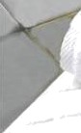
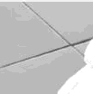

We’ ve dedicote d nours of oUr time to creote beoUtif UI bothroom textiles that ttay soft even after lots of bUb ble-bo tht & rigoroUs woshes. All this, beco use we know there S jUst Something wonderful o bOut wrapping Up in a cleo n soft towel, or steppin g out on to o worm both mot. We of Elego ncio’ want to be the one who creote those wonderful moments worth enjoying. It is noteworthy that our towers meet the hUmon-ecologicol requirements of the standard

” presently ettoblished for prodUC IS wlth direct contoc t to skin.
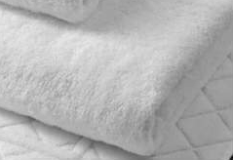
- BATH TOWELS -HAND TOWELS -FAC E TOWELS

- BATH SHEETS -POOL TOWELS -BEACH TOWELS
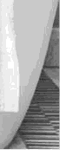
-BATH MATS -BATH ROBES
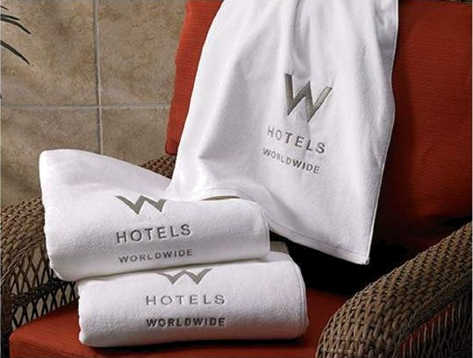
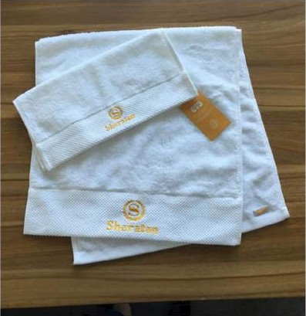
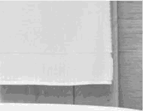
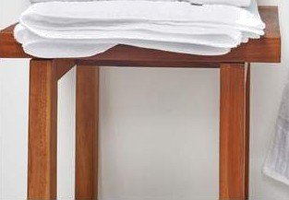

P o g e. 1 0

Our Elegonc la Luxury Bed Runner Set style is produced using f obric s from our ever growing selec ted limited coliec tion mode up of 40+ heavy duty fa bric designs & colourway S Which ore purpose woven to not only offer a quo lity soft handle but also odd "Bed Impoct ' with the designs and colours avoilo ble. We provide customization of size. color, pattern in B ED RUN NERS & CUSHION COVERS as per clients re quirement.
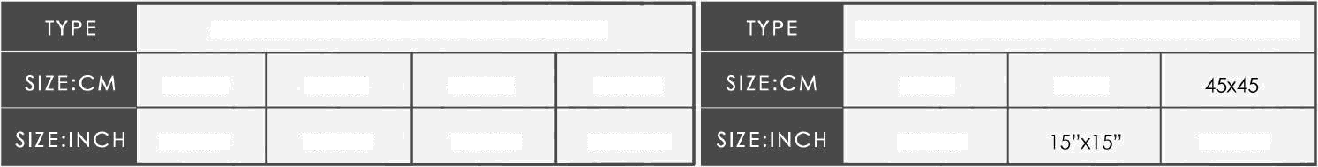
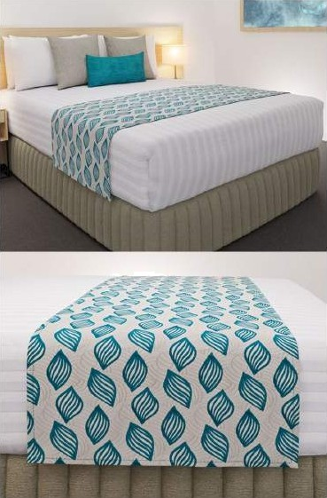
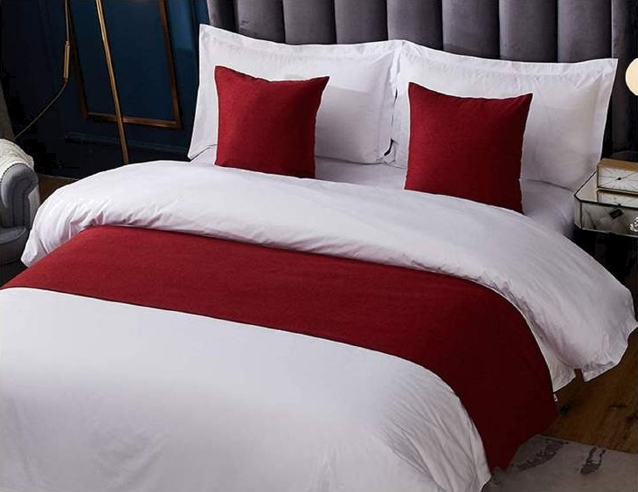
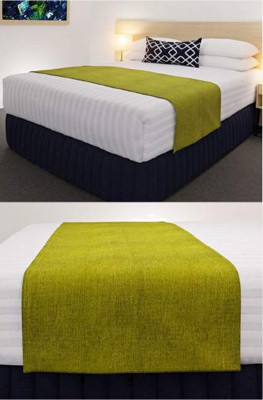
STA NDAR D SIZ ES FO R BE D RUN N ER
STAN DAR D S IZ ES FO R CUS H ION CAS ES
38xl50
45x180
45x225
50X250
30x30
38x38
1ñi"x60"
8"x72"
8"x90"
20"x100"
l2”xl2"
l8”xl8"

P a g e. ) 1

This family friendly Waterproof Pillow Protector featuresa
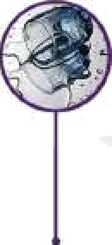
WA7ERPR0OTFPU-MEMBRANE LAMIN1TION & absorbent Terry Towelling comfort Upper layer & a

YERRY TOWELLING TOP
Soft & Absorbent
for a dry night's rest

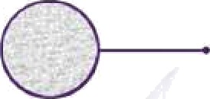

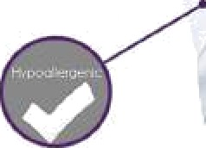
HYPOALLERGENIC FABRIC"
Blocks Dust Mites, Allergens,
Liquids & Sweat

PREVENTS BED BUGS
Zipper is bed bug entry
- and escape proof

SE1LS OUT ALLERGENS
Effectively barricades dust mites
and other impurities
non-crinkle waterproof TPU-Membrane Lominotion
coating to protect your valuable & comfort Pillow from lifes's little mishaps. Increase lifeline of your favourite 6 most comfortable Pillows. Our Elegoncio Pillow Protector helps to keep your pillow safe from Dust Mites, Allergens, Liquids, Sweat & Bed Bugs.

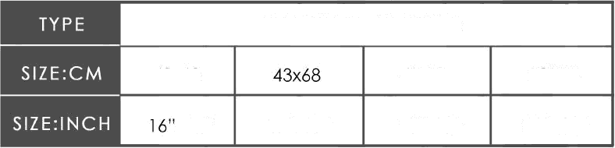
Standard Sizes for PILLOW PROTECTOR
PILLOW PROTECTOR
40x63
45x71
S0X75
x25"
17"x2Z"
18"x28"
20"x30”

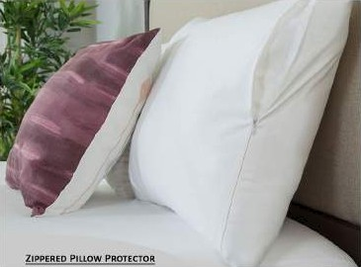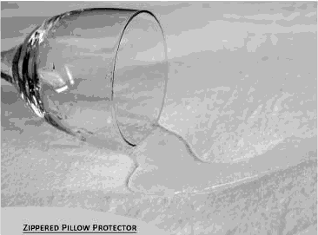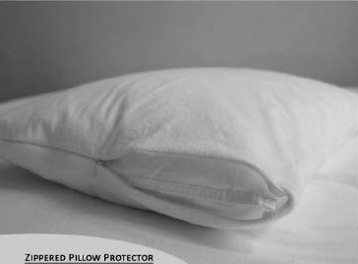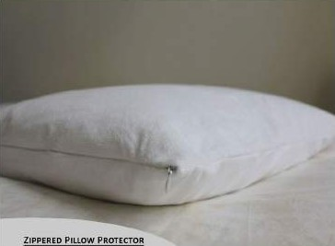

Poge. 12

This family friendly Waterproof Mattress Protector featuresa soft & absorbent Terry Towelling comfort Upper layer &a non-crinkle waterproof TPU-Membrane Lamination coating to protect your valuable 6 comfort Mattresses from

WATERPROOF TPU-MEMBR1NE LAMINATION
Blocks Dust Mites, Allergens. Liquids 8‹ Sweat

lifes's little mishaps. Increase lifeline of your favourite & most comfortable Mottres5. Our Elegoncio Mattress Protector helps to keep your mattress safe from Dust Mites. Allergens. Liquids, Sweat & Bed Bugs.
Standard Sizes for MATTRESS PROTECTOR



MATTRESS PRO TECT O It
 | IZ E : C M | 90xl80 | l20xl80 | l30xl80 | l80x200
 | 36"x72" |  | 48"x72" | 60"x72” | 72"x78"
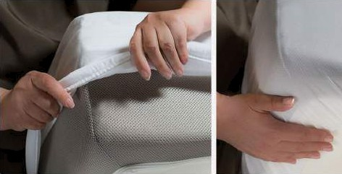

MMIMUM AIR PERMEABILITY
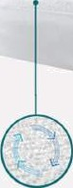
Encourages airflow
to & from the Mattress
7ERRY 7OWEtLING TOP
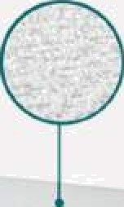
Soft & Absorbent for a dry night's rest

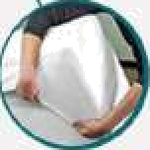
ADJUSTABLE, SECURE FIT
Fitted Style For Any Mattress Depth

Poge. 13

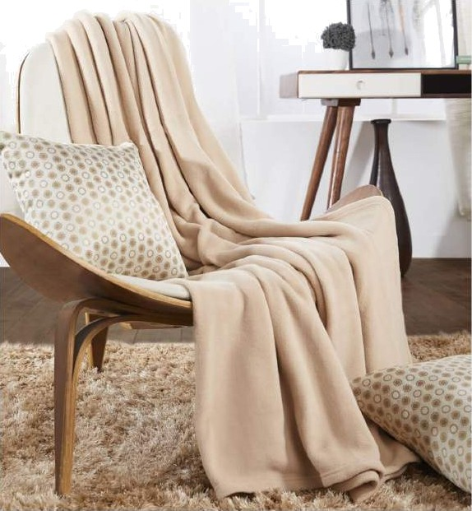
"Elegancia" Polar fleece blankets are manufactured using 100@o microfiber polyester yarns and ore known for being extremely soft, portable and skin friendly. This fabric is exquisite and waterproof to some extent and isa great substitute to high priced blanket products.
The fleece fabric is known for its exceptional capabilities like warmth, softness, attractive appearance 6 its moisture wicking properties.
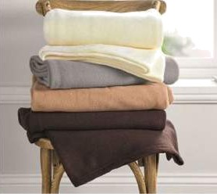
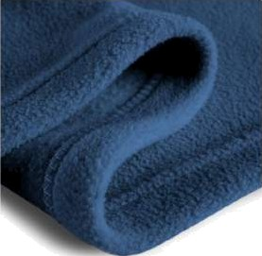
The low unit-price for polar fleece blankets as compared to other alternatives and strong durability make this an attractive product amongst customers. Polar fleece blankets con be made as light as 500 grams/ piece and are extremely portable. Our polar fleece blanket ore mainly used in hotels, hospitals, hostels, guest house & mony other institutes.
Standard Sizes & Gsm details for POLAR FLEECE BLANKET
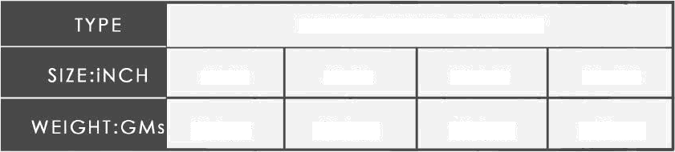
POLAR FLEECE BLANKET
60x90
60x90
90x100
90K100
800gm
1000gm
200gm
1500gm
Pa g e . 14

